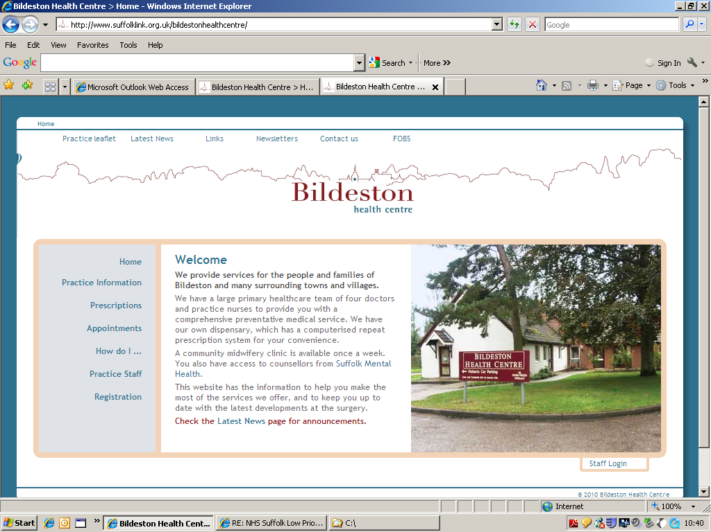
Dr Mark Hainsworth Bildeston Health Centre
Dr David Clark High Street Bildeston
Dr Louise Beale Ipswich IP7 7EX

Tel: 01449 740254

15 November 2021

BILDESTON HEALTH CENTRE

PPG MEETING MINUTES

Present from BHC: Carol Huxtable (Dr Mark Hainsworth popped in)

Present from BHC PPG: 4 Members

Present from Hadleigh & Boxford Group PPG (H&BG PPG): Jan Devey

An official Agenda was not available for this 2nd meeting of the BHC PPG. However, a member asked that 2 items be discussed at the meeting which were – Composition of the PPG and Correspondence between the Practice and PPG members.

After initial introductions were made the Chair of the Hadleigh and Boxford Group PPG gave an overview of their PPG.

The current Chair stepped in after the sudden resignation of the previous H&BG PPG Chair. Currently there are 12 core members who liaise closely with a GP and the Practice Manager at the practice. Both the latter attend the monthly meetings, which total approximately 6 per year. The H&BG PPG members arranged for the volunteers at the recent Covid-19 vaccination clinics and proved invaluable in aiding the smooth running of these clinics. The PPG is advertised with H&BG practice on a double noticeboard within the surgery and they have also set up a display of art works by local people.

Actions for BHC PPG members:

All members to

- Familiarise themselves with our website
- Look at other surgeries’ websites to see what their PPG’s do
- Provide links for our website ie link to Suffolk Libraries website for the loan of laptops
- A member to attend the upcoming PPG Network Meeting on 30.11.21

Items discussed/received after today’s meeting:

‘Rural Caravan’ / Loneliness

