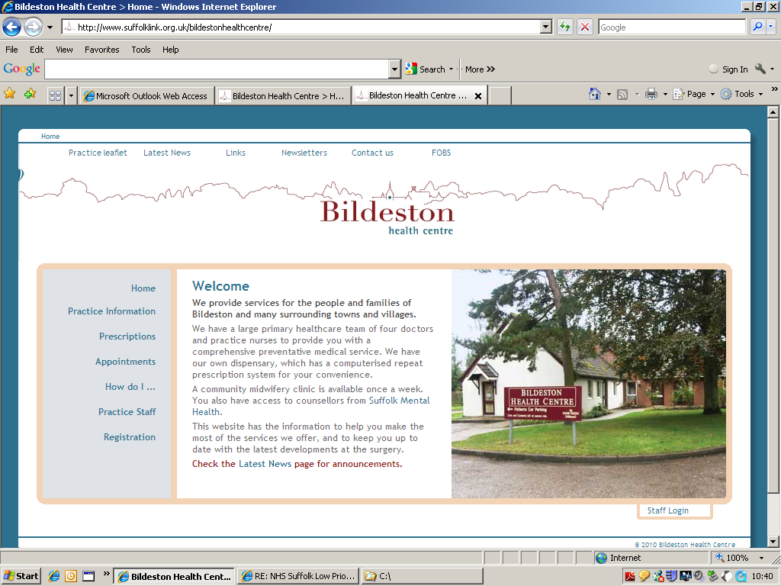
Dr Mark Hainsworth Bildeston Health Centre
Dr David Clark High Street Bildeston
Dr Louise Beale Ipswich IP7 7EX

Tel: 01449 740254

Monday 20 September 2021

BILDESTON HEALTH CENTRE
PATIENT PARTICIPATION GROUP
MINUTES OF MEETING HELD ON 20.9.21

Present from BHC: MH (GP) and CTH (Assistant Practice Manager)

PPG Members present: 4

This was the first meeting of the newly formed Bildeston Health Centre PPG, at which there was a general discussion as to the purpose of a PPG. The PPG is a Critical Friend of the Practice and each PPG works differently and how a PPG can be the representatives of the Community. The PPG liaises with one GP and Manager of the Practice, putting forward their ideas and suggestions to the Practice of ways in which the PPG can help build on the relationship between the practice and it’s patients, improve on services provided by the practice or by agencies associated with the practice. The PPG is not a forum for complaints or for personal issues to be discussed

Ideas / Suggestions discussed at today’s meeting included:

- Befriending Housebound patients

- Bereavement Support

- Newsletter

- I.T. Courses

- Laptops – loan of laptops from Libraries

- Recruiting New Members

The above ideas and suggestions will be discussed in depth at the next meeting on 20 December. However, 2 members have already been looking into some ideas: for instance, a link has been put on our website regarding the loan of laptops from Libraries and another has been looking at how many villages are within the boundary of Bildeston Health Centre with the aim of advertising the PPG within those villages.

Next meeting date: Monday 20 December 2021 at 1pm

If you are interested in joining our PPG, then please contact Carol Huxtable on 01449 740254 or by email to carol.huxtable@nhs.net and your details will be passed to our PPG members.

